**FEDERAL COLLEGE OF ANIMAL HEALTH & PRODUCTION TECHNOLOGY, VOM. DEPARTMENT OF COMPUTER SCIENCE**

**SECOND SEMESTER EXAMINATION 2017/18 SESSION**

***COURSE CODE/TITLE:*** *COM 223 (Basic Hardware & Maintenance)* ***TIME ALLOTED:****11/2hours*

**SECTION A:**  *Choose the appropriate option from the alternative answers provided in (a) – (d)*

1. All EXCEPT one is a type of resistor

(a) Carbon film (b) Metal Film (c) Metal Oxide Film (d) wire film

1. The relationship between current and voltage in ohm’s law is

(a) inverse (b) exponential (c) direct (d) linear

1. Select the Odd one among the following

(a) Closed Circuit (b) Open circuit (c) Long circuit (d) Short circuit

1. A resistor is color coded with green, orange, black, yellow and silver will have resistance and tolerance values of.

(a) *530 Ω, $±$ 0.1* (b) *530 X 10KΩ* , $±$ *0.1* (c) *530KΩ* , $±$ *0.01*(d) *530 X 10KΩ, $±$ 0.02*

1. A resistor with a resistivity of *0.0175 Ω mm/m will have a conductivity of*

(a) *57.1mm/Ω*  (b)*57.1m/Ω mm* (c) *57.1m/Ω* (d) *57.1Ω /mm*

1. *The steps taken to back up a system file include*

(a) *Open start Menu and click on control panel* (b) *Open back up and restore center* (c) *Select where to store the backed up files* (d) All of the above

1. The Circuit symbol in Figure 1 represents a ----------- resistor

(a) Variable (b) Fixed (c) Preset (d) all of the above

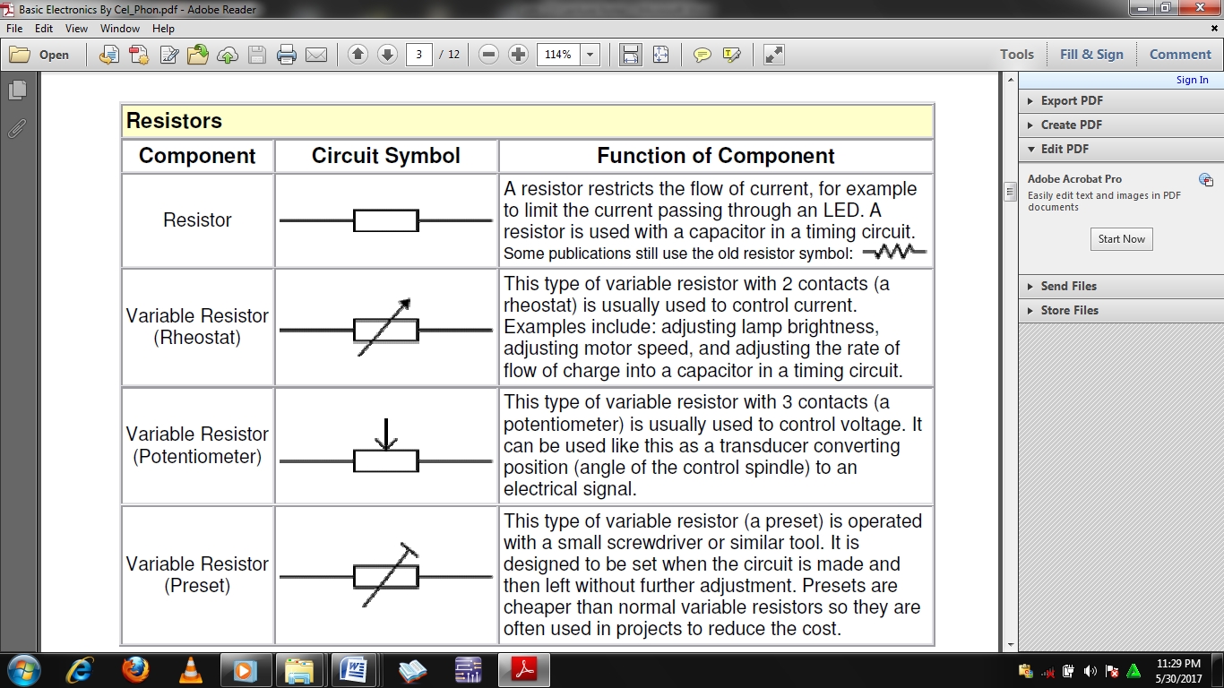

Figure 1

1. Which of these is Odd?

(a) Disk Cleaning (b) Disk defragmentation (c) Disk Scanning (d) Blowing

1. The Steps Involved In Computer Corrective Maintenance

(a) Define your symptoms (b) Identify and Isolate the Problem (c) Replace, Repair, Re-assembling (d) All of the above

1. Which of these cannot measured using the multimeter?

(a) Temperature (b) Current (c) Voltage (d) Resistance

**SECTION B:** *Validate the following as True or False*

1. Computer system diagnosis and troubleshooting are essentially the same.
2. *The two categories of computer system backups are incremental and complete backups*
3. Fault diagnosis can be achieved either by means of diagnostic tools or by trouble shooting.
4. Diagnostic tools refer to computer hardware used to asses what is wrong with a computer system.
5. Computer Viruses and Computer worms are essentially the same
6. Disk defragmentation and Disk scanning are essentially the same
7. Integration enhances miniaturization
8. Transistors can only function as switches
9. The AVO- meter is also known as the multi meter
10. The Multi- Meter is multi-functional but not multi-range

**SECTION C:** *Complete the table below;*

|  |  |  |
| --- | --- | --- |
| **S/N** | **Abbreviation** | **Full Meaning** |
| 1 | *POST* |  |
| 2 | *SIPs* |  |
| 3 | *PGAs* |  |
| 4 | *DIPs* |  |
| 5 | *SIMMs* |  |
| 6 | *DIMMs* |  |
| 7 | *LINs* |  |
| 8 | *LOGs* |  |
| 9 | *BIOS* |  |
| 10 | ULSI |  |

**SECTION D:** A*nswer any five (5) Questions*

1. Advance 10 reasons for computer system maintenance
2. List 10 typical computer maintenance activities.
3. List 10 useful applications of resistors in electrical and electronic hardware
4. Enumerate 10 effects of dust to computer hard ware
5. Outline the necessary steps in system disk defragmentation
6. List the factors that determine the resistance of a material and correlate them using an equation.
7. Give 10 reasons why Computer system devices averse to excessive currents